Tatton Wildlife Newsletter – Winter
During these uncertain times, the natural world has given valuable support to many people. To be able to escape, relax and recharge has proven to benefit everyone’s wellbeing. Tatton’s parkland provides an invaluable resource in this regard and the winter season brings many fantastic things to see and appreciate. There is still so much to see and discover!
Birds
Our winter visitors have now arrived. You will notice the increase of wildfowl species and numbers on the meres, our resident birds have now been joined by migrants from the north to enjoy our relatively mild climate. Winter thrushes such as redwing and fieldfare have also returned, they can be seen and heard in large numbers either flying over or feeding on the open grassland areas or stripping the berries from a suitable tree or bush. Bramblings can be found feeding on beech mast, as this is the favoured food of this close relative of our resident chaffinch. Beech Avenue and Rostherne Drive are good places to search for them. The reedy fringes of the meres are a good place to see a stonechat at this time of year, they often perch in prominent positions so are relatively easy to spot.
Now is also a good time to enjoy our woodland birds. Various species will gather together in large flocks to exploit food sources and with safety in numbers, hopefully avoid predators. These flocks include tits, goldcrests, woodpeckers, treecreepers and nuthatches, they may even be joined by an overwintering chiffchaff or blackcap. The lack of leaves also helps you to spot them!
Waxwing, smew, bittern and divers are rarer winter bird species to look out for too, they have all been seen here at Tatton in the past.
A juvenile black-necked grebe was seen on Tatton Mere at the end of September and stayed with us for a few days. They are a very uncommon species that has a breeding stronghold nearby, so it probably ventured from there. Many people were lucky enough to photograph it including the one above taken by a member of staff.
Deer
In early winter the deer concentrate on restoring condition after the exertions of the rut and by late November, even if grass is readily available, the rangers will commence supplementary feeding. The research behind this is that it is better to start then as the deer become familiar with the feeding regime early and to catch any weaker animals before their bodyweight falls too drastically before the harsher weather sets in. This especially applies to late born calves and fawns that will not gain any weight after Christmas until spring when a metabolic slowdown takes place. They are fed daily with carrots and added concentrate feed, sometimes haylage too depending on the severity of the weather and availability of grass. The tenant sheep flock was removed in early November, saving winter grass supplies for the deer.
The deer have now moulted to their much drabber winter coats. These are thicker and the longer guard hairs which are hollow trap air, this warms and provides more insulation.
Butterflies
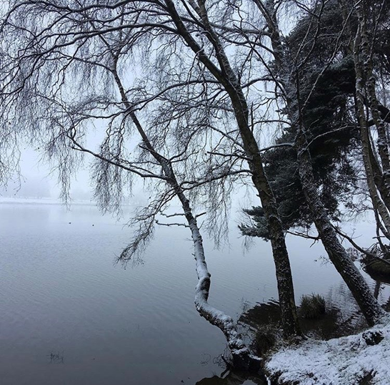
The ranger team have continued to survey the parkland butterfly transect, but this has been heavily impacted by the effects of the pandemic and we’ve only been able to complete just over half the walks we did last year. But nevertheless, there has still been plenty to see on the transects we have completed. In line with national trends, some species emerged earlier during the warm spring, good numbers of meadow brown and gatekeeper were seen later in the year, although small and green veined whites tended to dominate towards the end. After only seeing one individual small copper last year, more were spotted in 2020, including some which appeared in a different part of the transect. Still no ‘blues’ seen on transect this year, but holly blue were present elsewhere in the park, so we live in hope for next year!
Compiled by Tatton’s Ranger Team

